DevOps

Linux 2

History 2

Linux Commands 5

Basic Commands 6

User Privileges 6

File and Directory Management 6

Viewing and Manipulating File Contents 6

File Comparison and Searching 7

Sorting and Filtering 7

Directory Navigation 7

System Information and Help 7

Service Management (Systemd) 8

Network and Connectivity 8

Package Management 8

Compression and Archiving 9

Environment Variables 9

Utilities and Calculations 9

User and Group Management 9

File Permissions 10

Package Management (YUM) 10

Web Server Configuration (Apache and Nginx) 10

System Monitoring and Hardware Information 11

File Transfer 11

# Linux

## History

**Linux and Windows Operating Systems - An Overview**

**1. Operating System Evolution and History**

* **Windows:**
  + DOS (Disk Operating System) - Also known as **MS-DOS**
  + Features:
    - Single User, Single Process
    - GUI-based (Graphical User Interface)
    - Uses **color-coded interfaces**
* **Linux:**
  + **Command Line Interface (CLI)** based
  + Uses **black color themes** for terminal operations
  + **Multi-User, Multi-Process** operating system
  + **Open Source and Free**
  + Known for being:
    - **Portable** (runs on different hardware)
    - **Secure**
    - **Multi-Tasking**
    - **Multi-User**

**2. Early Development and Key Contributors**

* **Ken Thompson (1960s)**:
  + Developed the **UNIX kernel**
  + Initially, UNIX was **not portable**
* **Dennis Ritchie**:
  + Known as the **Father of the C Language**
  + Improved UNIX to make it **portable and free (open source)**
* **Andy (1980s)**:
  + Developed **Minix** - an enhanced UNIX version, but **not free**
* **Linus Torvalds (1991)**:
  + A student from Finland who wanted to develop his own kernel
  + Inspired by **Minix**, but did not get a positive response from Andy
  + Developed the **Linux kernel** independently
  + Linux is **Free and Open Source**
  + The Linux logo is a **penguin**

**3. Linux vs Windows**

|  |  |  |
| --- | --- | --- |
| Feature | Windows | Linux |
| Interface | GUI (Colorful, Visual) | CLI (Command Line, Black Background) |
| Task Handling | Single User, Single Process | Multi-User, Multi-Process |
| Licensing | Proprietary | Open Source |
| Portability | Limited | Highly Portable |
| Security | Vulnerable to attacks | Known for high security |

**4. Linux File System Hierarchy**

The Linux file system follows a hierarchical structure starting from the **root (/) directory**.  
Below are the major directories and their purposes:

|  |  |  |
| --- | --- | --- |
| Directory | Purpose | Example Paths |
| / | Root directory | / |
| /bin | Binaries and executables | ls, cat, cp |
| /boot | Boot loader files and the kernel | Kernel images |
| /etc | Configuration files and startup scripts | /etc/nginx/nginx.conf |
| /home | User directories | /home/raj, /home/tom, /home/ec2-user |
| /var | Variable files such as logs and spool files | /var/log, /var/www |
| /tmp | Temporary files | /tmp/session123 |

**5. Command Structure in Linux**

The structure of Linux operations consists of several layers:

1. **Hardware Layer**: Physical devices like CPU, RAM, and disk.
2. **Kernel Layer**: Interface between hardware and user applications.
3. **Shell Layer**: Command-line interpreters like **bash**, **ksh**, and **csh**.
4. **Command Layer (CLI)**: User commands executed through the shell.

**6. Common Linux Commands**

|  |  |  |
| --- | --- | --- |
| Category | Command | Purpose |
| Directory | cd | Change directory |
|  | mkdir | Create a new directory |
|  | rmdir | Remove a directory |
| File | ls | List directory contents |
|  | touch | Create an empty file |
|  | cp | Copy files or directories |
|  | chmod | Change file permissions |
|  | chown | Change file ownership |
| Viewing | cat | Display file contents |
|  | head | Show the first few lines of a file |
|  | tail | Show the last few lines of a file |
| Process | ps | Display current processes |
|  | pwd | Print working directory |
| Package | yum (RPM) | Package manager for RedHat-based distros |
|  | apt (Debian) | Package manager for Debian-based distros |
| HTTP Server | httpd | Apache HTTP server in RPM-based distros |
|  | apache2 | Apache HTTP server in Debian-based distros |

**7. Linux Distributions**

Linux distributions (distros) are categorized based on the package management system:

* **RPM-based:**
  + RedHat, CentOS, Amazon Linux 2 (AL2)
  + Uses **YUM** as the package manager
* **Debian-based:**
  + Ubuntu, SUSE
  + Uses **APT** as the package manager

**8. Summary**

* Linux evolved as a powerful, open-source, and portable alternative to UNIX.
* It supports multi-user and multi-process operations, unlike early Windows systems.
* The Linux kernel is at the heart of all Linux-based systems, providing an interface between hardware and applications.
* The file system structure and command-line tools make it highly versatile for server and development environments.
* Linux distributions vary mainly in package management and system architecture but share core kernel functionalities.

## Linux Commands

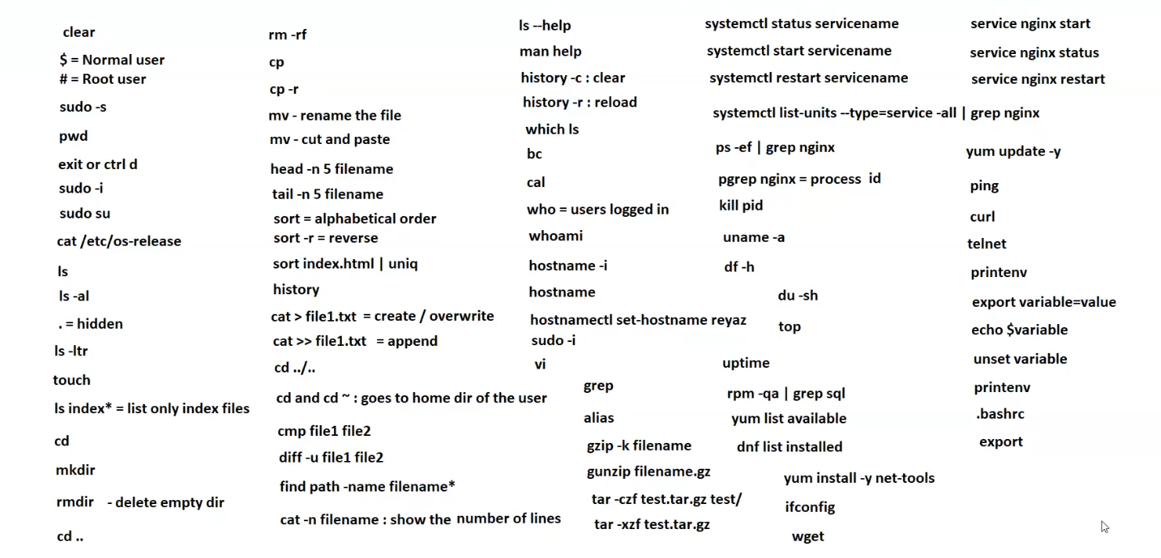

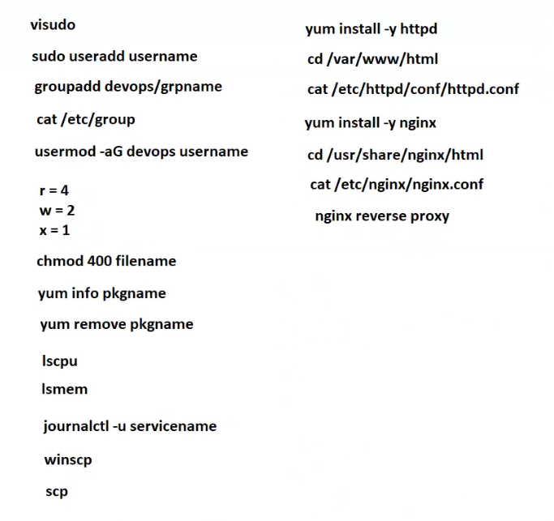

### Basic Commands

* clear - Clears the terminal screen.
* exit or ctrl + d - Exits the terminal session.

### User Privileges

* $ - Normal user prompt.
* # - Root user prompt.
* sudo -s - Switch to root user shell.
* sudo -i - Switch to root user with login shell.
* sudo su - Become the root user.
* whoami - Display the current logged-in username.

### File and Directory Management

* pwd - Print working directory (shows the current directory).
* ls - List directory contents.
* ls -al - List all files (including hidden) in long format.
* ls -ltr - List files sorted by modification time in reverse.
* ls index* - List only files with names starting with "index".
* mkdir - Create a new directory.
* rmdir - Remove an empty directory.
* rm -rf - Force remove files and directories recursively.
* touch - Create an empty file or update the timestamp.
* cp file1 file2 - Copy file1 to file2.
* cp -r dir1 dir2 - Recursively copy directory1 to directory2.
* mv oldname newname - Rename or move a file or directory.
* mv (cut and paste) - Move files or directories.

### Viewing and Manipulating File Contents

* cat /etc/os-release - Display OS release information.
* cat > file1.txt - Create or overwrite file1.txt.
* cat >> file1.txt - Append data to file1.txt.
* cat -n filename - Display the content with line numbers.
* head -n 5 filename - Display the first 5 lines of a file.
* tail -n 5 filename - Display the last 5 lines of a file.

### File Comparison and Searching

* cmp file1 file2 - Compare two files byte by byte.
* diff -u file1 file2 - Compare files line by line with unified output.
* grep - Search text using patterns.
* find path -name filename* - Search for files by name pattern.
* grep sql - Search for "sql" keyword in output.
* ps -ef | grep nginx - Search for Nginx processes.
* pgrep nginx - Get process ID of Nginx.

### Sorting and Filtering

* sort - Sort lines of text files alphabetically.
* sort -r - Sort lines in reverse order.
* sort index.html | uniq - Sort and remove duplicate lines.

### Directory Navigation

* cd - Change to the home directory.
* cd .. - Move up one directory level.
* cd ../.. - Move up two directory levels.
* cd ~ - Go to the user’s home directory.

### System Information and Help

* ls --help - Show help for the ls command.
* man help - Display the manual for help.
* hostname - Display the hostname of the system.
* hostname -i - Display the IP address associated with the hostname.
* hostnamectl set-hostname reyaz - Set the system hostname.
* history - Display command history.
* history -c - Clear the command history.
* history -r - Reload the command history.
* who - Show who is logged in.
* which ls - Show the path of the ls command.
* uname -a - Show detailed system information.
* df -h - Display disk space usage in human-readable format.
* du -sh - Show the size of the current directory.
* uptime - Show system uptime.
* top - Display active processes.
* rpm -qa - List all installed RPM packages.
* rpm -qa | grep sql - Find SQL-related installed packages.

### Service Management (Systemd)

* systemctl status servicename - Check the status of a service.
* systemctl start servicename - Start a service.
* systemctl restart servicename - Restart a service.
* systemctl list-units --type=service --all - List all services.
* service nginx start - Start Nginx service.
* service nginx status - Check Nginx status.
* service nginx restart - Restart Nginx service.

### Network and Connectivity

* ifconfig - Display network interfaces and IP addresses.
* ping - Check connectivity to a host.
* curl - Transfer data from or to a server.
* telnet - Connect to a remote host.
* wget - Download files from the internet.

### Package Management

* yum update -y - Update all packages.
* yum list available - List available packages.
* yum list installed - List installed packages.
* yum install -y net-tools - Install net-tools package.
* dnf list installed - List installed packages using DNF.

### Compression and Archiving

* gzip -k filename - Compress a file without deleting the original.
* gunzip filename.gz - Decompress a file.
* tar -czf test.tar.gz test/ - Create a compressed archive.
* tar -xzf test.tar.gz - Extract a compressed archive.

### Environment Variables

* printenv - Print all environment variables.
* export variable=value - Set an environment variable.
* echo $variable - Display the value of an environment variable.
* unset variable - Unset or remove an environment variable.
* .bashrc - Configuration file for Bash shell.
* export - List all exported variables.

### Utilities and Calculations

* bc - Basic calculator.
* cal - Display a calendar.
* alias - Create command shortcuts.

### User and Group Management

* visudo - Safely edit the /etc/sudoers file to grant sudo privileges.
* sudo useradd username - Create a new user account.
* groupadd devops/grpname - Create a new group named devops or grpname.
* cat /etc/group - Display the list of groups and their members.
* usermod -aG devops username - Add a user to the devops group.

### File Permissions

* **Permission Values:**
  + r = 4 (Read)
  + w = 2 (Write)
  + x = 1 (Execute)
* **Permission Syntax:**
  + The permission numbers are combined to set permissions:
    - chmod 400 filename - Set read-only permission for the owner (no permissions for group and others).

### Package Management (YUM)

* yum info pkgname - Display information about a package.
* yum remove pkgname - Uninstall a package.
* yum install -y httpd - Install Apache HTTP server.
* yum install -y nginx - Install Nginx web server.

### Web Server Configuration (Apache and Nginx)

**Apache (HTTPD)**

* Configuration File:
  + cat /etc/httpd/conf/httpd.conf - Display the Apache configuration file.
* Default Document Root:
  + cd /var/www/html - Navigate to the default web directory.

**Nginx**

* Configuration File:
  + cat /etc/nginx/nginx.conf - Display the Nginx configuration file.
* Default Document Root:
  + cd /usr/share/nginx/html - Navigate to the Nginx web directory.
* **Nginx Reverse Proxy:**
  + A reverse proxy setup to direct client requests to backend servers.

### System Monitoring and Hardware Information

* lscpu - Display detailed information about the CPU.
* lsmem - Display information about system memory.
* journalctl -u servicename - View logs related to a specific service.

### File Transfer

* winscp - A GUI tool for file transfer over SCP, SFTP, or FTP (Windows).
* scp - Secure copy for transferring files between hosts over SSH.